## 

## **Hello everyone… It's Nintendo Society News Time!**

Thank you to everyone who visited us at our SocsFair stall! We hope to see a lot of new (and old) faces at our taster events this week! We were flattered by the interest shown at the fair so bear with us if it is busy as we are a new society and we want to try and put on fun events for all!

Because of this, if you own any consoles / controllers yourself which you would like to bring along then we would appreciate this a lot! Absolutely no worries if you can’t though as we will provide as much equipment as we own!

And with that, here are this week's announcements:



### **Monday 9/10, R1.13 & R1.15 (Ramphal Building), 5pm setup, 6-10pm**

Manic Mondays are all about enjoying Nintendo games! We will have 3DS’s, Wii U’s and Switch’s around for all of you to have a play on some of Nintendo’s finest games!



### **Wednesday 11/10, R0.03/4 (Ramphal Building), 1pm setup, 2-10pm**

This is our weekly Smash Bros. event! Wednesdays are dedicated gaming sessions for Super Smash Bros. for Wii U and Melee! Open to all skill levels from complete casual to more competitive level, and we will have multiple setups of each! For those wanting to try out more competitive Smash, we will look to hold a tournament from ~5pm.

Feel free to show up during the setup time, it’s more to allow us to get everything connected!

If you don’t know where the Ramphal Building is on campus then use the following link! We will have a banner outside the room to indicate where we are! <https://campus.warwick.ac.uk/?cmsid=18&project_id=1>

---------------------------------------------------------------------------------------

And that’s all the time we’ve got! Until next time…

Don’t get cooked… Stay off the hook! :D

Timothy Sit

Nintendo Society President

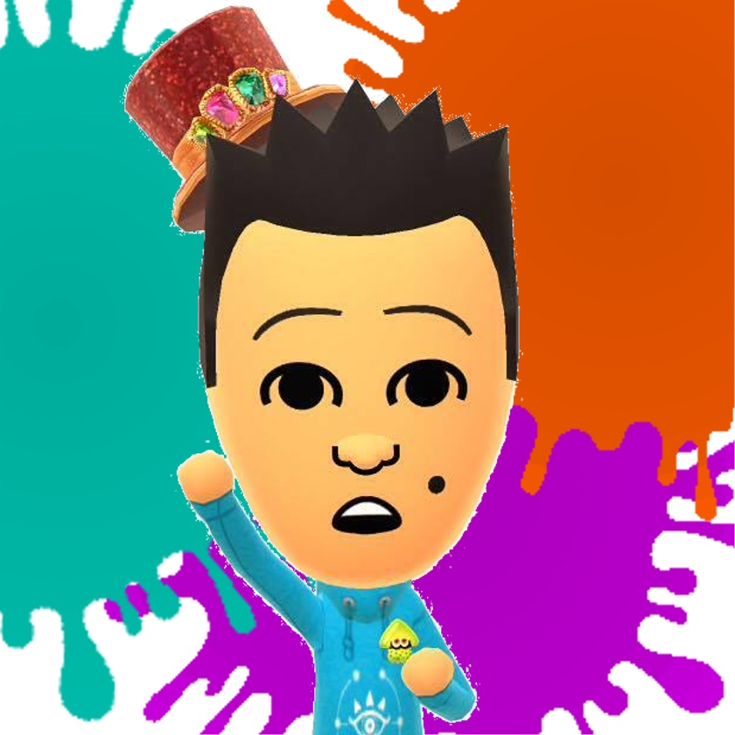

---------------------------------------------------------------------------------------

### **Find us on Social Media:**

Join our Facebook group:<https://www.facebook.com/groups/warwicknintendo/>

Follow our Twitter:<https://twitter.com/warwicknintendo>

Join our Discord Chat:<https://discordapp.com/invite/Rf6QyfG>

Subscribe to our YouTube:<https://www.youtube.com/channel/UCzO_bZNfQDCAQa_zkEUgGVg>